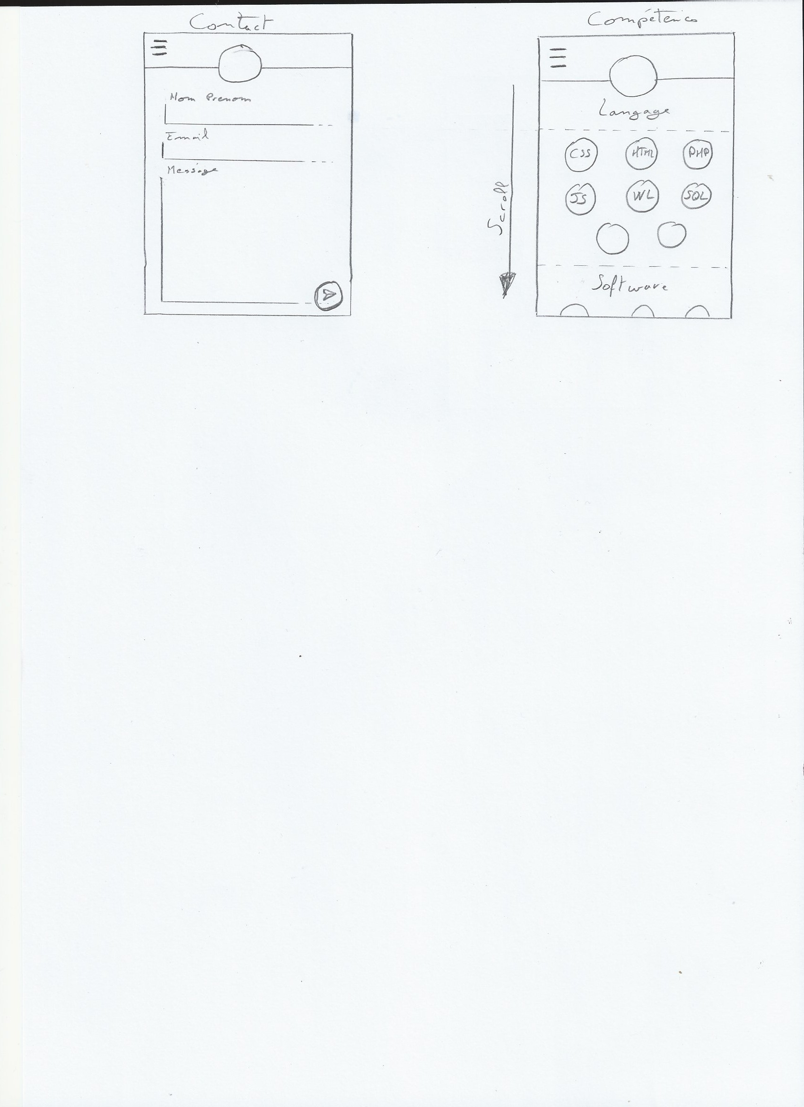Brief portfolio Yohann COUPANNEC.

New mobile application project.

The application must be mobile hybrid andwill target a professional audience in IT development .

It will put forward my skills, my studies and projects I worked on.

Used technology

-          Angular 2

-          Ionic Framework

-          Apache Cordova

-          SQL

-          Node.js

Page layout:

-          Menu

o Summary

-          Presentation page

o Name

o First name

o Age

o Photo

o City

o Work or current training

-          Page competence

o Name of the skill

o Presentation of competence

o Logo of the competence

-          Training page

o Name of training

o Start/end date

o Presentation of the training

-          Project page

o Name of the project

o Presentation of the project

o Technology used

o Start/end date

-          Activity page Activity = Hobby ?

o Title of the activity/leisure

o Description

o Logo of the activity/leisure

-          Contact page

o Possibility of contact by mail

The project will be on GitHub in open access and completely in English even if it will be possible to choose the language between English or French.

It must respect a strict naming: yohannc-portfolio. As well as the use of the lowerCamelCase for declaring variables, function, class etc.

